Discrete Mathematics
Course Code : 3341
Diploma in Artificial Intelligence and Machine Learning
Semester : 3

There are two major branches in Mathematics :
- Continuous Mathematics
- Discrete Mathematics
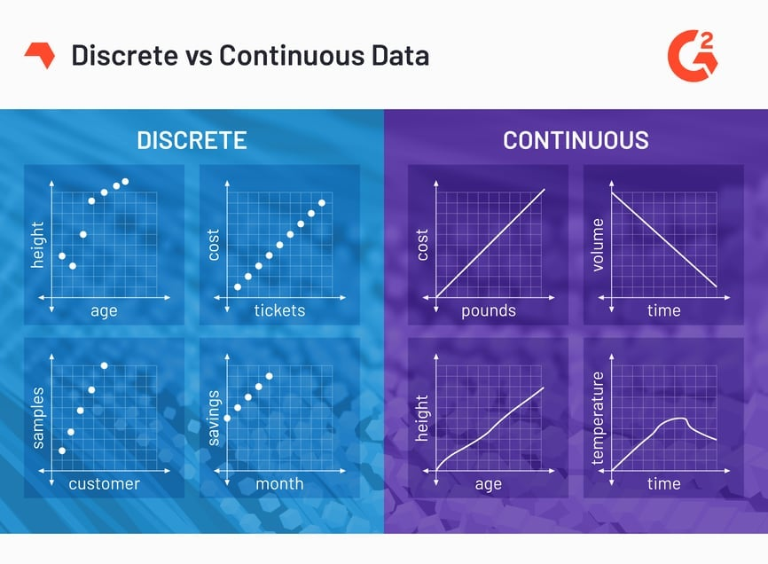

Continuous Mathematics Discrete Mathematics
Result of measuring Result of counting
Can take any values Can have only specific values
Eg : height = 160.5 cm Eg : number of students in a class

